***STAAD Pro Integration Testing  
AUTOPIPE 11.0.0.13***

**STAAD Pro using PipeLink**

|  |  |
| --- | --- |
| **Test Scope** | STAAD Pro export using PipeLink |
| **Performed By** | Hasnain Raza Sarwar |
| **Date** | 21st November, 2016 |
| **Machine** | Windows 10, 64bit |
| **Description** | Verification of the ability to export an existing AutoPIPE model into the STAAD Pro and vice versa |
| **Models** | Integ_auto1.dat, Integ_sample1.std, Integ_sample1.pipelink |
| **Testing Status** | Pass |
| **AutoPIPE version** | 11.00.00.13 |
| **STAAD Pro version** | 20.07.11.82 |

**Exporting from STAAD to AutoPIPE:**

*Starting in STAAD then export the structure to evaluate combined structural and piping stiffness in AutoPIPE*

1. Open structure model Integ_sample1.std in STAAD Pro, and Analyze (Analyze>Run Analysis)



1. Click on “Piping” tab and then export this structure to AutoPIPE (Piping>Export). Select folder to save and click on start run  .pipelink file will be created.

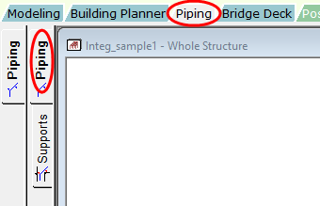 

1. Now open DAT model (Integ_auto1.dat) from AutoPIPE examples folder

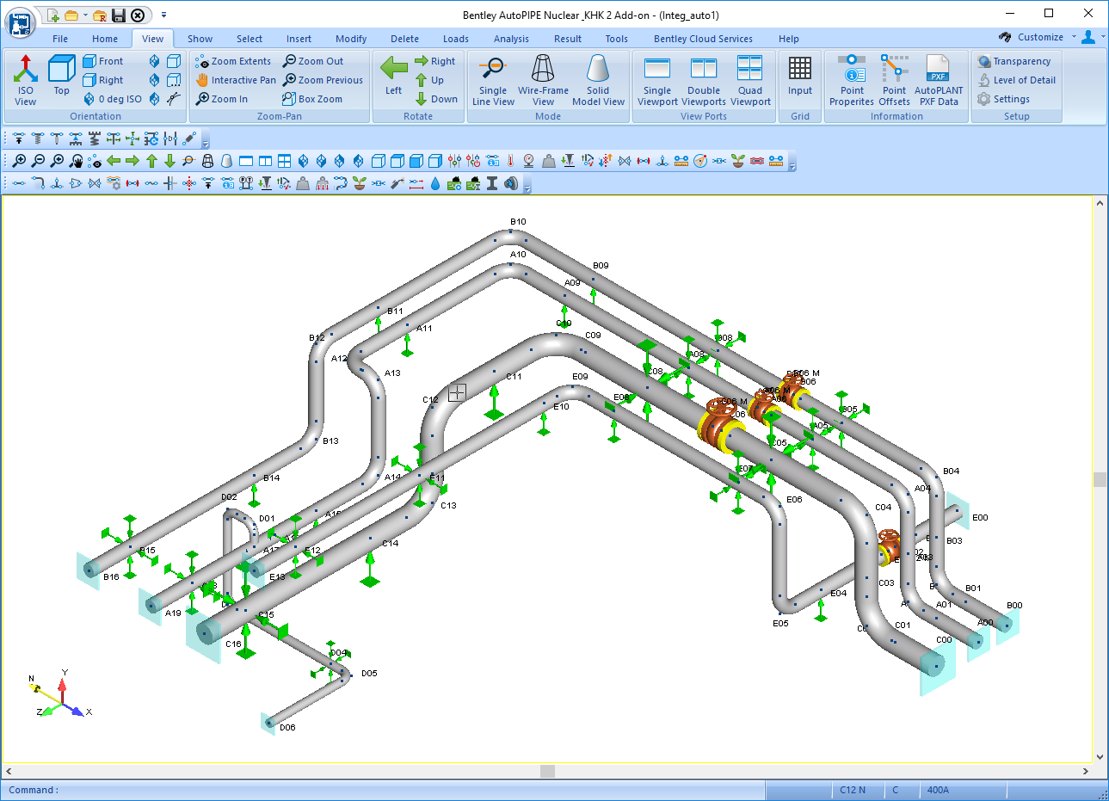

1. Analyze the model (Analysis > Analyze > Analyze All).
2. For Insert:

* Insert STAAD structure (Integ_sample1.pipelink) into Integ_auto1.dat piping model (File>Insert Model> Model from STAAD using PipeLink (*.pipelink)).

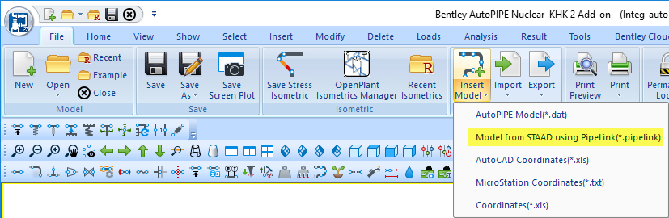

* Import it by checking
* 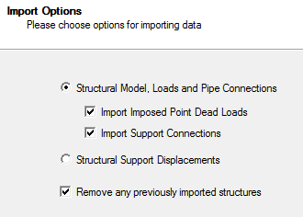“ Structural Model, Loads and Pipe Connections” option
* “Import Imposed Point Dead Loads” option
* ”Import Support Connections” option
* “Remove any previously imported structures” option

Click next and structure will be inserted into AutoPIPE model.

1. A “Review Imported Support Connections” window will be prompted, on this window a user can review any of the imported support connections and can accept or reject the connection by checking or unchecking the check box under “Accept Connection” column.

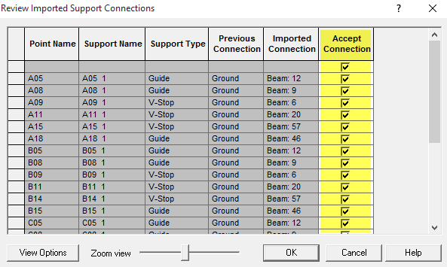

**Note:** All the support connections are successfully imported from STAAD and new nodes are assigned automatically.

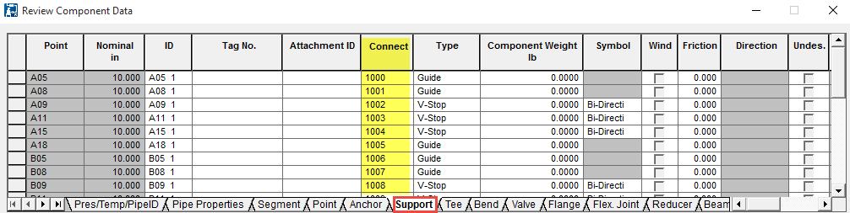

1. Analyze (Analysis > Analyze > Analyze All) the new model after insertion in AutoPIPE.

**Exporting from AutoPIPE to STAAD:**

1. Open AutoPIPE and open model “Integ_auto1.dat” from examples folder.



1. To analyze the model for Gravity, thermal & Seismic loadings invoke Analysis > Analyze > Static Analysis Sets

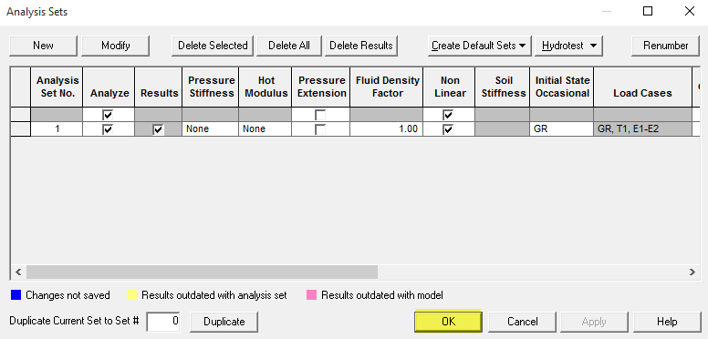

1. Carry out the static analysis on the model, invoke Analysis > Analyze > Static
2. To generate AutoPIPE load combination descriptions, go to Results > Combinations (click on non-code combinations)
3. Click on “Combination Options” and select “Generate default non-code descriptions”

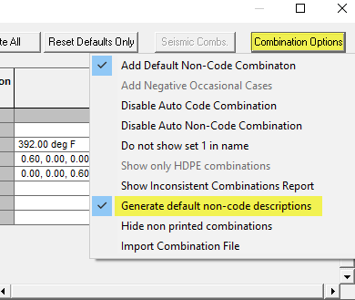

**Note:** during export program (AutoPIPE) will export all load cases and code & non-code combinations

1. Export the model to STAAD using Pipelink by invoking File>Export>Model to STAAD using PipeLink (*.pipelink) [model provided in Test Models folder as model_export_AutoPIPE_to_STAAD (Step6).Pipelink]

**Note:** Make sure check box “Export Support Loads” is checked

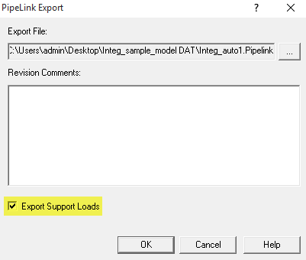

1. Open STAAD.Pro and open example model “Integ_sample1.std”
2. Click on “Piping” tab and Import the model created in step 6

 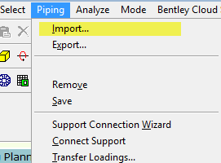

1. Run the STAAD Support Connection Wizard to Connect all or some Supports to the Structure (first time the Support connection Wizard will start automatically)
2. Select “All” to connect all available supports to the structure, and click next

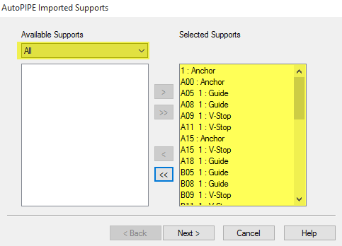

1. Select “All” to consider all beams for connection

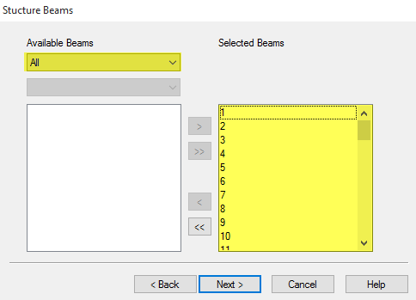

1. Select “All” to consider all beam nodes for connection

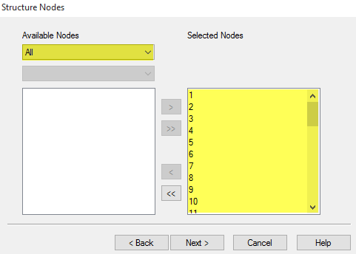

1. Click next on Structure/Pipe Connectivity Parameters dialog

**Observe that:**

Connections are successfully made

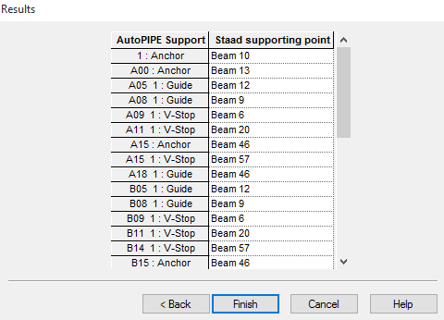

Dotted lines shows the connection made

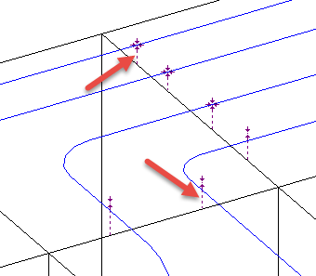

1. To transfer piping loads to structure, move to “Supports” tab and invoke Piping > Transfer Loadings

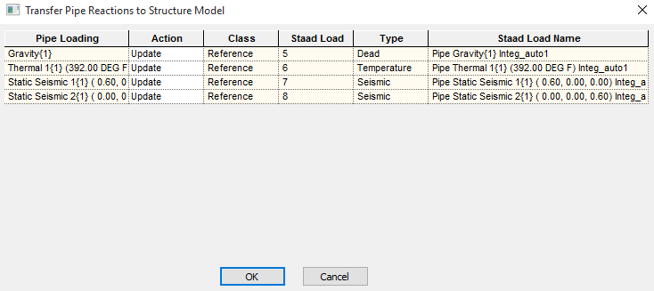

**Exporting user made structure to AutoPIPE:**

1. Open STAAD.Pro and go to File > Configure, change Base Unit to English
2. Click on New Project, select “Plane” with length and Force units as foot & Kilo Pound respectively, and click next

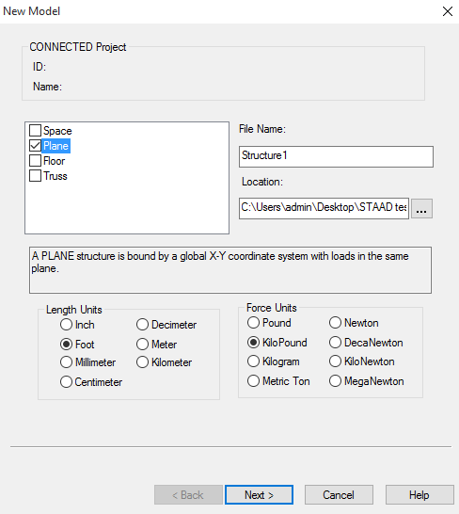

1. To make a beam with user specifications, select “Open Structure Wizard” and click Finish
2. On the Structure Wizard (StWizard), change model type to “Frame Models and double click on Continuous Beam
3. Give Length 10 ft and No. of bays along length 1, and apply

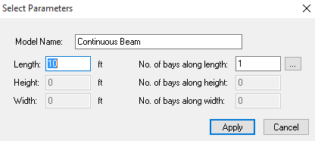

1. Invoke File > Merge Model with STAAD.Pro Model
2. Give coordinates X: -5.00, Y: -0.83, Z: -5.00

Note: Y is given -0.83 since the diameter the of pipe is 0.83 in, this will make the pipe sit on the beam

1. Click on the Geometry > Beam tab, and make sure that nodes are showing with correct coordinates.

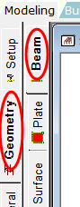 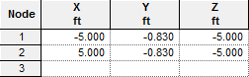

1. Now click General tab, On the “Properties-Whole structure” (input dialog box at bottom right of the screen), click on “Define”

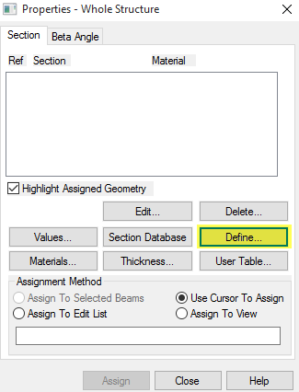

1. On the Property dialog window, select Tapered I and give the following values (shown in snap below), and click Add then close the dialog box

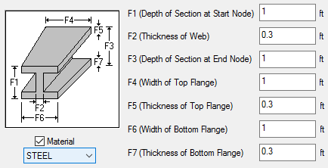

1. Again on the “Properties-Whole structure” window, click assign and move the cursor on the beam and click
2. Now go to General > Support tab, on the “Supports-Whole structure” window, click create
3. Add the “Fixed” support
4. Select the support and click assign, move the cursor to the end nodes and click to apply fixed supports on these nodes. The end result should look like the snap below:

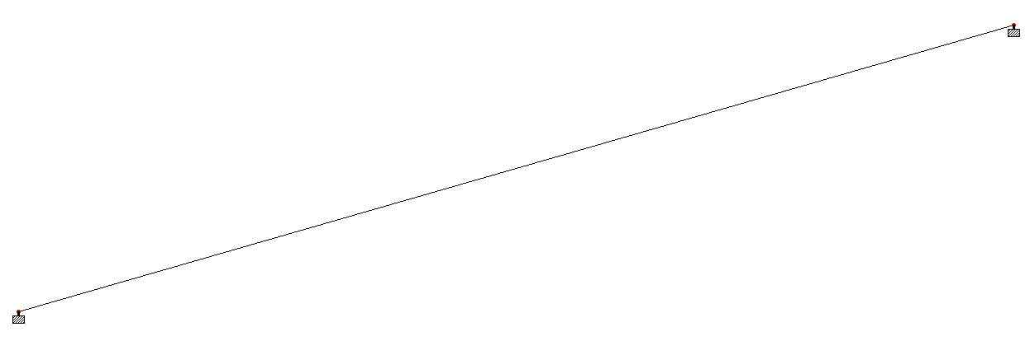

1. Click on the horizontal tab “Piping”, Analyze the structure (Analyze>Run Analysis)
2. Export the structure to AutoPIPE using Pipelink, Piping > Export (Follow same steps as described in earlier workflow) [provided in Test Models folder as STAAD_test_beam.std]
3. Now open AutoPIPE and make a new model with the following specifications:
   * + B31.1 Power (2014)
     + Units: ENGLISH
     + Nominal Diameter: 10 in.
     + A00: (0,0,0), A01: (0,0, -5), A02: (0,0, -10)

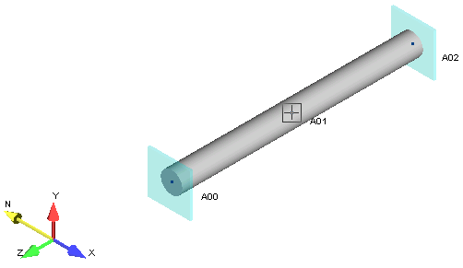

1. On the AutoPIPE command ribbon, invoke File > Insert Model > Model from STAAD Using PipeLink (*.pipelink) (browse to the structure and open)

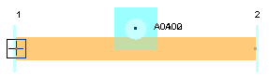Observe that the structure (Beam) is successfully inserted into the model

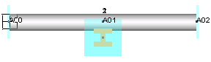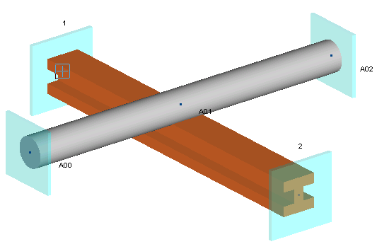 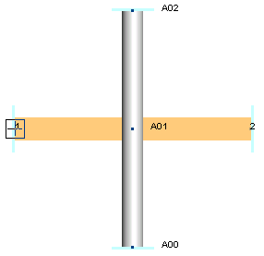

**Conditions Tested:**

| **CONDITIONS** | **PASS/FAIL** |
| --- | --- |
| All graphic and textural information passed from AutoPIPE to STAAD Pro through PipeLink are “workable” in that environment. | PASS |
| No omissions of translatable information | PASS |
| No STAAD crashes or Hangs | PASS |
| STAAD model is importable to AutoPIPE | PASS |